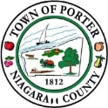
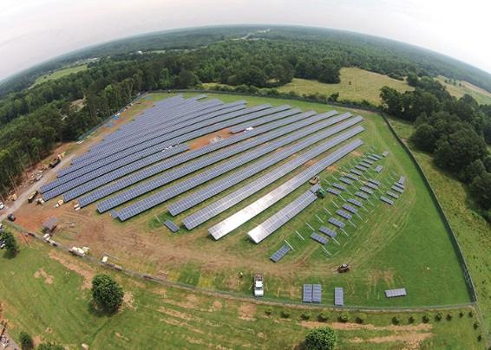
TOWN of PORTER
3265 Creek Road ♦Youngstown, New York 14174 ♦
♦ (716)745-3730, ext. 7♦ (716) 745-9022♦
Code Enforcement office ♦ porterbuildinginspector@roadrunner.com ♦
Facts:
- 25 MW (MegaWatt)/ INDUSTRIAL SOLAR and Larger Systems are not regulated by the Town of Porter (the Town has no direct authority to regulate Industrial Solar (>25 MW); New York State has taken the authority from local municipalities through Article 10 of NYS Public Service Law)
- Town of Porter Adopted Local Law 7 of 2019 (L.L.7-2019) – Solar Energy Systems (previous Solar regulations limited Ground mounted Solar to 1000 Square Feet)
- Town’s L.L.7-2019 provides specific restrictions for all types of Solar Energy Systems except for Industrial size (>25 MW, which are regulated by and permits issued by NYS).
- Town’s L.L.7-2019 defines three categories of Solar Energy Systems;
- December 12, 2019
- Solar Energy System Information
  - Tier 1 Solar Energy Systems are: Roof-mounted solar energy system, and or Building integrated solar energy systems.
  - Tier 2 Solar Energy Systems are: Ground-mounted solar energy systems with system capacity up to 25 kW AC or 1,750 square feet total surface area of all solar panels on the parcel and that generate no more than 110% of the electricity consumed on the site over the previous 12 months.
  - Tier 3 Solar Energy Systems are systems that are not included in the above indicated Tier 1 and Tier 2 solar energy systems; Except Industrial size (25 MW or larger, which are regulated by and permits issued by NYS). In other words, Tier 3 Solar include 0.25 MW thru 24.9 MW Solar Energy Systems only.
- Town of Porter purpose/intent upon adoption of L.L. 7-2019 is as follows:
    - (1) This solar energy section is adopted to advance and protect the public health, safety and welfare of the Town of Porter by creating regulations for the installation and use of solar energy generating systems and equipment, with the following objectives:
    - (a) To take advantage of a safe, abundant, renewable and nonpolluting energy resource;
    - (b) To decrease the cost of electricity to the owners of residential and commercial properties, including single-family dwellings;
    - (c) To increase employment and business development in the Town of Porter, to the extent reasonably practical, by furthering the installation of solar energy systems;
    - (d) To mitigate the impacts of solar energy systems on environmental resources such as important agricultural lands, forests, wildlife and other protected resources; and
    - (e) To create synergy between solar and the Town of Porter's Comprehensive Plan, which, in "Principle 3 of A Comprehensive Plan for the Town of Porter," states "improve the quality of our environment" as a principal goal.
- National Grid Has Sub Stations and Transmission Lines in the Town of Porter that will accept/allow for added Commercial Grade Solar Energy Systems to the capacity limit of the respective Sub Stations and Transmission Line equipment. If added capacity will be required, National Grid will evaluate and determine/control the process to upgrade or not to upgrade.
(Continued on next page)

- Town’s L.L.7-2019; Summary of Tier 3 Solar Energy Systems key OVERSIGHT components:
  - Special Use Permit is required to be approved or approved with stipulations from the Town’s Planning & Zoning Boards. The Boards have authority to stipulate additional restrictions on a case by case basis.
  - Benefit to the community:
    - [1] Community solar shall account for a minimum of 40% of the total system's output of electricity, per parcel/system; or
    - [2] Alternatively, an approved alternative community benefit may be considered; or
    - [3] Alternatively, a payment in lieu of a community solar energy system.
  - Tree-cutting: Removal of existing trees larger than six inches in diameter should be minimized to the greatest extent possible.
    - (a) Removal of tree(s) larger than six inches in diameter may be allowed if offset by planting at least two trees, three inches in diameter, of like in kind species on the respective parcel. Approval of alternative tree species and/or size, other than "like in kind," shall be determined by the Planning Board.
- Decommissioning:
    - (a) Solar energy systems that have been abandoned and/or not producing electricity for a period of six months shall be removed at the owner and/or operator's expense, which at the owner's option may come from any security made with the Town of Porter as set forth in upcoming section herein.
    - (b) If the use of any Tier 3 solar energy system is discontinued, the provider/operator shall notify the Town of Porter Code Enforcement Officer within 90 days of such discontinuance.
    - (c) A decommissioning plan (see Appendix 4) signed by the owner and/or operator of the solar energy system shall be submitted by the applicant, addressing the following:
      - [1] The cost of removing the solar energy system.
      - [2] The time required to decommission and remove the solar energy system and any ancillary structures.
      - [3] The time required to repair any damaged caused to the property by the installation and removal of the solar energy systems.
      - [4] Notification of discontinuance, by owner/operator to the Town of Porter.
- Town of Porter Adopted Local Law 8 of 2019 (L.L.8-2019) – Solar Energy Systems P.I.L.O.T. (Payment In Lieu Of Taxes) Law;
  - Purpose - This Local Law is adopted to ensure that the benefits of the community’s solar energy resource are available to the entire community, by promoting the installation of solar energy generating equipment through a payment-in-lieu-taxes (PILOT), granting reduced costs to system developers and energy consumers, and providing a revenue stream to the entire community.
- FOR COMPLETE LANGUAGE OF THE SOLAR ENERGY SYSTEMS LAW GO TO:
  - https://ecode360.com/16127215#16127215 ON THE INTERNET.

Feel Free to call or email Peter T. Jeffery, Town of Porter Code Enforcement Officer with any questions, during normal business hours: (716) 745-3730, extension 7; or email porterbuildinginspector@roadrunner.com
Additional Information & Definitions:
Agricultural Resources - Ground-mount solar installations are commonly cited on agricultural land. In New York State, agricultural land in certain areas of the State are protected under the Agriculture and Markets Law, specifically Article 25AA of the Agricultural Districts Law. Part 1 of the EAF requires a calculation of the impact to productive agricultural soils regardless of whether the project is located in a State-certified Agricultural District. Applicants may wish to consult the Department of Agriculture and Markets document Guidelines for Agricultural Mitigation for Solar Energy Projects;
( https://agriculture.ny.gov/system/files/documents/2019/10/solar_energy_guidelines.pdf )
The NYSERDA factsheet Understanding Solar Installations in Agricultural Districts (https://s3.amazonaws.com/assets.cce.cornell.edu/attachments/17180/NYSERDA_Fact_Sheet_-Solar_Installations_in_Ag_Districts.pdf?1471276425 ) provides guidance on frequently asked questions. The NYS Department of Agriculture and Markets may be an Interested Agency in the SEQR process and may become an Involved Agency depending on the nature of the impact.
Capturing revenue from installations without opting out of RPTL§ 487 (Community Benefit) - The law allows jurisdictions that offer the RPTL § 487 exemption (Town of Porter does) to negotiate payments in lieu of taxes (PILOTs). The purpose of a PILOT is to reduce the tax burden and tax rate uncertainty on the property and/or system owner, while preserving some of the forgone revenue that would have been paid in property taxes. PILOTs are often used for large-scale14 renewable energy projects, including solar electric systems. They are annual payments commonly related to the system’s size (often in dollars per megawatt [MW]) and cannot exceed the amount of taxes that would be owed without the exemption. Each taxing jurisdiction (except the school districts of New York, Buffalo, Rochester, Syracuse, and Yonkers) that has not opted out of RPTL § 487 may require the owner of a solar installation to enter a PILOT. The PILOT may not exceed a 15-year term, but it cannot require payments that exceed the value of taxes that would be paid without the exemption provided by RPTL § 487.15 PILOT agreements can be an effective tool for jurisdictions to generate comparable revenue without making solar costs prohibitive for most homeowners and businesses.
Community Solar - In addition to residential, commercial, and municipal projects, a relatively new kind of solar project, “community solar,” has emerged as an efficient and affordable way for all New Yorkers to gain access to clean energy. Community solar allows individuals (including renters and others who cannot install a system on their own roof) to purchase individual panels or some fraction of the electricity a large-scale solar energy system generates. These customers receive credits for this electricity on their monthly utility bills. A community solar project benefits a community and its residents in several ways. Community solar customers—which may include municipalities, businesses, and residents—save money on their utility bills. Taxing jurisdictions can benefit from additional revenue through payment-in-lieu-of-tax (PILOT) agreements. Farmers generate revenue by leasing parts of their land. At the same time, given the passive nature of a solar energy system, a solar project does not create increased demands on municipal services and infrastructure. A community solar project brings revenues and benefits to a community and its residents in several ways.
New York State has committed to generating 50% of its electricity from renewable energy sources by 2030, increasing the demand for land used for solar energy generation.
Community solar projects are much larger than residential rooftop projects and are typically ground-mounted in rural areas, sometimes on agricultural land. A typical 2 MW AC community solar project will require about 10 acres of land. However, solar development is significantly constrained by several factors, including utility infrastructure, the locational cost of electricity, zoning policies and state policies.
There may be some potential for agricultural uses on the same site as solar energy systems, including grazing livestock. Planting wildflowers for pollinator purposes on marginal or abandoned agricultural land can also provide some added benefit. In addition, the underlying land could be returned to agricultural use if properly restored at the end of the solar energy system lifecycle. A balanced approach that allows solar development and adequately preserves agricultural land is necessary.
Net metering – Any power produced by a Solar PV system that is not consumed on site is pushed into the utility grid. The Solar PV system owner receives credit for this production on their monthly utility bill. Utilities typically install a meter at Solar PV sites, which tracks the amount of electricity taken from and fed into the utility grid.
Net metering: A common feature of grid-connected solar PV systems whereby excess electricity produced by a solar array is fed back into the utility grid. System owners can earn credits on future energy bills for the excess electricity their systems generate. The credits can then be used later when homeowners need power from the local utility, such as at night or on cloudy days.
Power purchase agreement: PPAs are becoming a popular way for homeowners to take advantage of solar power without the financial responsibility associated with installation costs. Under the agreement, a third party installs the solar PV system and the homeowner agrees to buy the electricity (kWh) it generates, typically at a rate lower than what the utility offers.
Remote Net Metering – Remote net metering: A variation on net metering whereby a solar PV system’s production is credited to an electricity consumer(s) located at a different physical site.
Site Plan & Special Use Permits - For many municipalities in agricultural districts, it is necessary to consider the short- and long-term needs of farmers, while also supporting the development of solar in their local communities. While sometimes this can be a challenge, there are two land-use tools that are commonly used in New York State to address this issue; special use permits and site plan regulations. These two land-use tools are used for siting large-scale solar energy systems in agricultural districts, while also allowing local officials to ensure that farmers valuable and productive farmland remains in operation.
Solar Photovoltaic (PV) is a technology that converts sunlight (solar radiation) into direct current electricity by using semiconductors. When the sun hits the semiconductor within the PV cell, electrons are freed and form an electric current. Solar PV technology is generally employed on a panel (hence solar panels).

- 1 MW = 5 to 6 acres of Solar Panels (PV);
- 5 MW = 25 to 30 acres of Solar Panel (PV);
- 10 MW = 50 to 60 acres of Solar Panel (PV).
- 1 MW = 1000 kVA; 1 x 1000 kVA = 1000 Kilovolt Ampere.
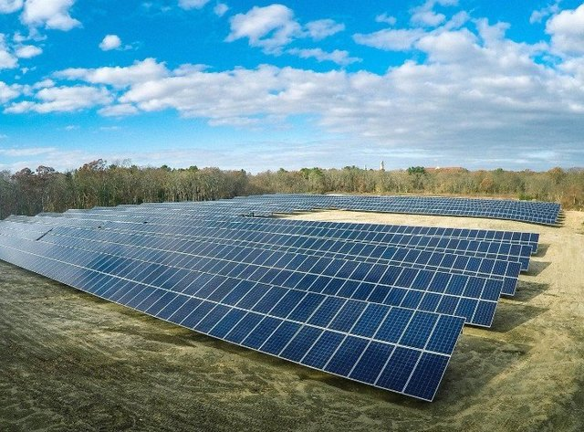

Town of Porter 12/16/19 - ptj

